ADK (Python Programming) ROLL NO 04

Aim: Write the program for the following: (by using control statements and control structure)

(E). Write a function to check the input value is Armstrong and also write the function for palindrome.

Theory: -
Practical Implementation:-
# Python program to check if the number provided by the user is an Armstrong number or not
def armstrong(num):
num=0
# find the sum of the cube of each digit
temp=num
while temp>0:
digit=temp%10
sum+=digit**3
temp//=10
# display the result
if num == sum:
print(num,"is an armstrong number")
else:
print("is not an armstrong number")

def palindrome(num):
n=num
rev=0
while num !=0:
rev=rev *10
rev=rev +int(num%10)
num=int(num/10)
if n== rev:
print(n,"is pelindrome number")
else:
print(n,"is not palin")

# take input from the user
num=int(input("enter a nummber to check it is armstrong or not:"))
armstrong(num)
# take input from the user
num=int(input("enter a number to check it is palindrome or not:"))
palindrome(num)
output:-

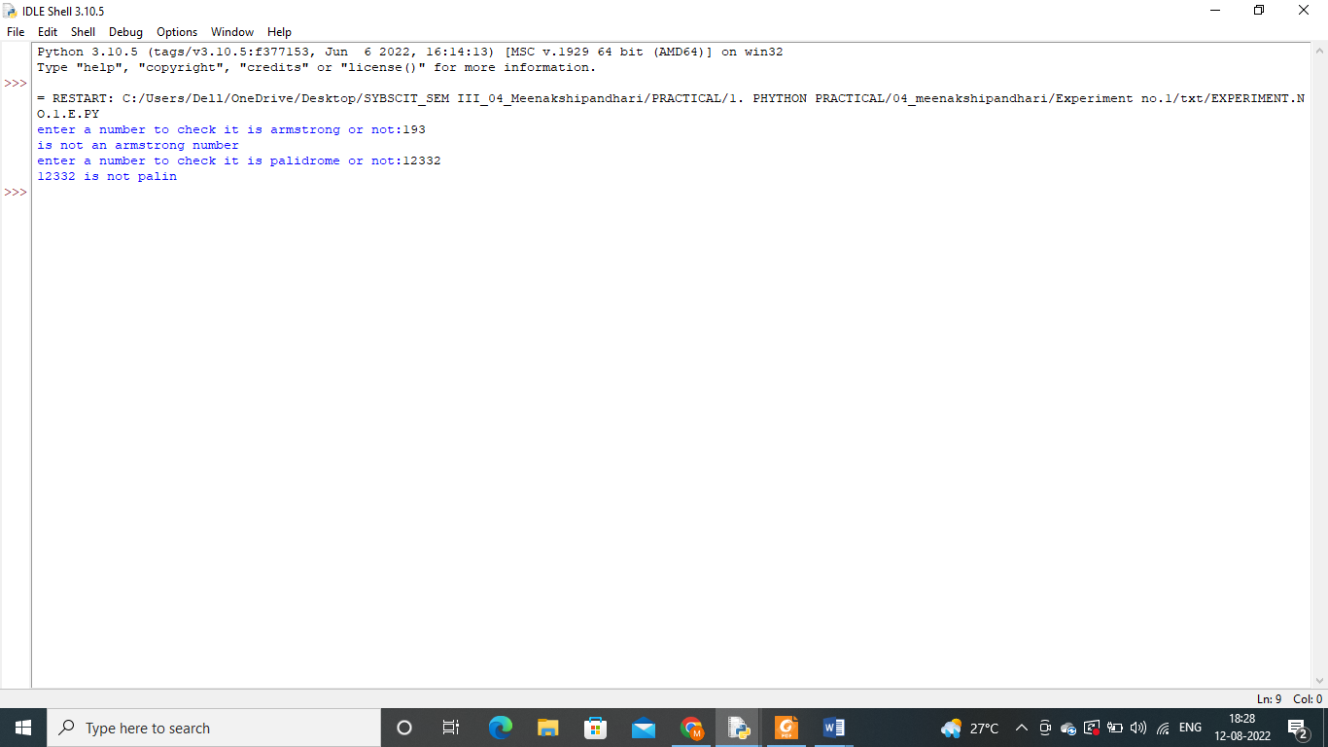

Conclusion:-

